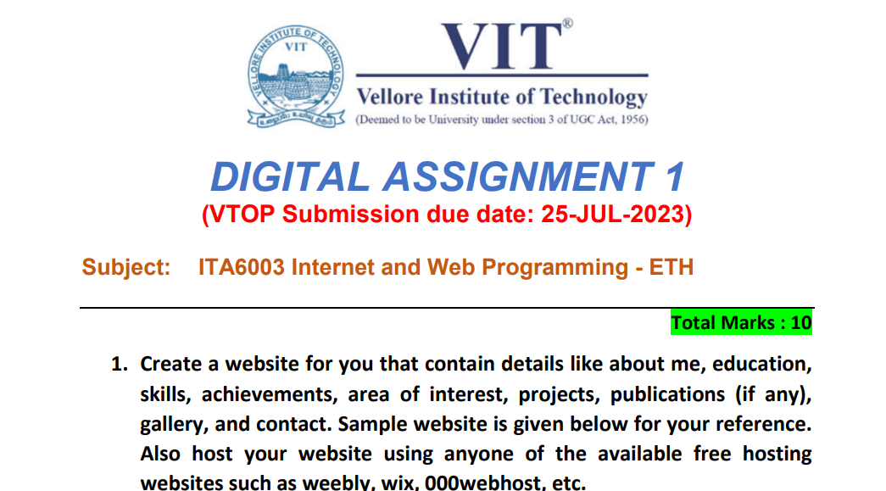

**Name:** Manvendra Gosain

**Registration Number:** 22MCA0321